**Lab Report**

Title: Exploration of the Esri Ecosystem

Notice: Dr. Bryan Runck

Author: Taryn Reitsma

Date: 2024-09-12

**Project Repository:** <https://github.com/taryn-reitsma/GIS5571/tree/main>

**Google Drive Link:** *<if applicable with data, notebooks, etc.>*

**Time Spent:** *<report to the nearest quarter hour>*

**Abstract**

*<Delete this text in light grey throughout>*

*250 words max. Clearly summarize the following major sections. Each gets one or two sentences.*

**Problem Statement**

Explore the varying functionalities within the Esri ecosystem by performing a buffer on a dataset provided by the Minnesota Geospatial Commons using three different environments: ArcGIS Pro, Jupyter Notebooks in ArcGIS Pro, and Jupyter Notebooks in ArcGIS Online.

Table 1. *<insert caption>*

|  |  |  |  |  |  |  |
| --- | --- | --- | --- | --- | --- | --- |
| **#** | **Requirement** | **Defined As** | **(Spatial) Data** | **Attribute Data** | **Dataset** | **Preparation** |
| 1 | Road network in Rice County | Raw input dataset from MnDOT for Rice County and 911 Center | Road geometry | Road location and address range information | [Mn GeoSpatial Commons](https://gisdata.mn.gov/dataset/us-mn-state-metc-trans-fnctnl-cls-rds) | Project into NAD83 UTM Zone 15N |

**Input Data**

Describe the data in two paragraphs max. Fill out the table.

Table 2. <insert caption>

|  |  |  |  |
| --- | --- | --- | --- |
| **#** | **Title** | **Purpose in Analysis** | **Link to Source** |
| 1 | Roads, Rice County, Minnesota | Raw input data from MnDOT for road network analysis | [Mn GeoSpatial Commons](https://gisdata.mn.gov/dataset/us-mn-state-metc-trans-fnctnl-cls-rds) |

**Methods**

*Figure 1. Data flow diagram.*

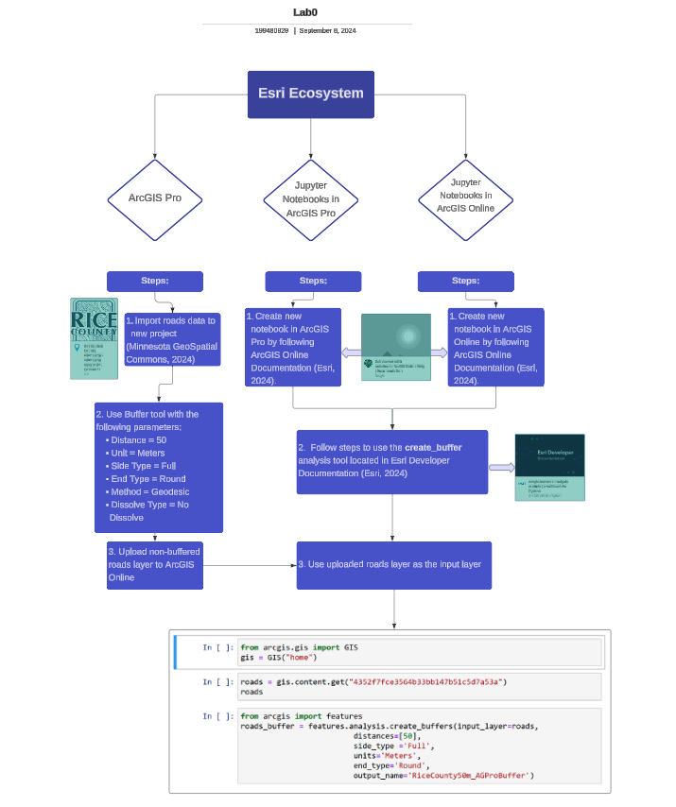

**Results**

*Show the results in figures and maps. Describe how they address the problem statement.*

*Follow best practice for map design, coloring, etc.*

**Results Verification**

*How do you know your results are correct? This can be a qualitative or quantitative verification.*

**Discussion and Conclusion**

GitHub

I was able to move quickly through the GitHub tutorials, since I use it at my job frequently. It took me a little bit to figure out how to create the folders in the desktop app, but overall, I did not struggle too much. I think it will take some practice for me to use GitHub on my own device. There are pretty strict regulations with using GitHub through my company, so I am not used to having as much freedom.

**References**

*Use a common format*

**Self-score**

*Fill out this rubric for yourself and include it in your lab report. The same rubric will be used to generate a grade in proportion to the points assigned in the syllabus to the assignment.*

|  |  |  |  |
| --- | --- | --- | --- |
| **Category** | **Description** | **Points Possible** | **Score** |
| **Structural Elements** | All elements of a lab report are included **(2 points each)**:  Title, Notice: Dr. Bryan Runck, Author, Project Repository, Date, Abstract, Problem Statement, Input Data w/ tables, Methods w/ Data, Flow Diagrams, Results, Results Verification, Discussion and Conclusion, References in common format, Self-score | 28 |  |
| **Clarity of Content** | Each element above is executed at a professional level so that someone can understand the goal, data, methods, results, and their validity and implications in a 5 minute reading at a cursory-level, and in a 30 minute meeting at a deep level **(12 points)**. There is a clear connection from data to results to discussion and conclusion **(12 points)**. | 24 |  |
| **Reproducibility** | Results are completely reproducible by someone with basic GIS training. There is no ambiguity in data flow or rationale for data operations. Every step is documented and justified. | 28 |  |
| **Verification** | Results are correct in that they have been verified in comparison to some standard. The standard is clearly stated **(10 points)**, the method of comparison is clearly stated **(5 points)**, and the result of verification is clearly stated **(5 points)**. | 20 |  |
|  |  | 100 |  |